**Frontend Project Report**

on

# Ecommerce Shopping Site

# Using HTML, CSS and JavaScript

# Bachelor of Engineering

## in

**COMPUTER SCIENCE AND ENGINEERING**

Submitted by:

**Aditya Bhatt (Roll no: 2110990084)**

**Group-5**

Under the supervision of

**Mr. Lavish Arora, CSE Dept.**



**CHITKARA UNIVERSITY INSTITUTE OF ENGINEERING AND TECHNOLOGY**

**Rajpura, Punjab**

## Department of Computer Sc. & Engineering

### ACKNOWLEDGEMENT

I would like to extend our heartfelt gratitude to the individuals and organizations who played a significant role in the successful completion of my college front-end project developed with JavaScript, HTML, and CSS. Their invaluable support and contributions were instrumental in the creation of this project.

I would like to thank:

Our Instructor Mr. Lavish Arora, who provided me with guidance, knowledge, and the opportunity to explore and apply front-end development skills. His support and mentorship were indispensable throughout this project.

Open-Source Community: The open-source community, which provided an array of resources, libraries, and tools that made the development process smoother and more efficient. I greatly appreciate the open-source contributions that fueled my project.

College Support Services: The college's support services, including the library, IT department, and administrative staff, who made resources, facilities, and technical assistance available to me during this project.

This project allowed me to apply the knowledge and skills I acquired during my college education. It was a valuable learning experience, and I am grateful for the opportunities it provided.

I am committed to continuous improvement and the pursuit of knowledge in the field of front-end development. This project marks the beginning of my journey, and I am excited to take what I have learned into my future endeavors.

Thank you to everyone who contributed to this project's success.

Sincerely,

Aditya Bhatt

2110990084

Chitkara University

CONTENTS

----------------------------------------

Acknowledgement……………………………………………………………………….. i

Introduction………………………………………………………………………………..ii

Goal and Challenges…………………………………………………………..iii

Project Overview……………………………………………………………….. iv

Why choose ELECTRONICS……………………………………………….. v

Future Scope……………………………………………………………………….. vi

**CHAPTER 1: INTRODUCTION**

* 1. **Objective:**

Welcome to my college front-end project, a showcase of my skills and knowledge in web development. This project was created using JavaScript, HTML, and CSS to demonstrate my ability to design a user-friendly and visually appealing website. Our primary focus was on delivering an exceptional user experience while applying best practices in front-end development.

This project allowed us to apply what I have learned and gain practical experience in the field. It reflects my dedication to web development and showcases my problem-solving and skills. In the following sections, I will delve into the project's features and technologies used to bring it to life. Thank you for joining me on this journey through my project.

* 1. **Introduction to technology used to make project:**

To develop this project, HTML has been used majorly where different methodologies and tools were applied. Vs Code was the greatest help in developing the above project. More on the technologies and methods used for the project can be seen below:

**HTML:** HTML stands for Hypertext Markup Language. It is the standard markup language used to create and structure content on the World Wide Web. HTML is the backbone of most web pages and is used to define the structure, elements, and layout of a web page, including text, images, links, forms, and multimedia.

HTML uses a system of tags to mark elements on a web page. These tags provide instructions to web browsers about how to display the content. For example, you can use HTML tags to create headings, paragraphs, lists, links, and more.

**CSS:** CSS stands for Cascading Style Sheets. It is a stylesheet language used for describing the presentation and visual design of web pages written in HTML and XML. CSS allows web developers to control the layout, formatting, and appearance of elements on a web page, such as text, images, links, and more.

CSS achieves this by defining rules that specify how HTML elements should be displayed. These rules consist of selectors and declarations. CSS provides a wide range of properties and values that can control everything from colors and fonts to spacing, borders, and positioning. It allows web developers to create visually appealing and responsive web designs while keeping the HTML content separate from its presentation. This separation of content (HTML), presentation (CSS), and functionality (JavaScript) is a fundamental concept in web development, known as the "separation of concerns."

**JavaScript:** JavaScript is a versatile and widely used programming language primarily employed in web development but also increasingly used in other areas, such as server-side development and mobile app development. JavaScript allows developers to add interactivity, manipulate the Document Object Model (DOM), and enhance the functionality of websites and web applications.

Key features and uses of JavaScript include:

* Client-Side Scripting: JavaScript is primarily used on the client side of web development. It runs in the user's web browser, allowing developers to create dynamic and interactive web pages. It can respond to user actions, validate forms, update content, and much more.
* DOM Manipulation: JavaScript can access and modify the Document Object Model (DOM), which represents the structure and content of a web page. This enables dynamic content updates and interaction with HTML and CSS elements.
* Event Handling: JavaScript is used to respond to various events, such as clicks, keyboard input, and form submissions. This allows for user-friendly interfaces and responsive Ib applications.
* AJAX (Asynchronous JavaScript and XML): JavaScript is essential for making asynchronous requests to web servers, allowing data to be loaded and updated without requiring a full-page refresh. This technology is commonly used to create responsive, real-time web applications.
* Cross-Browser Compatibility: JavaScript is supported by all major web browsers, making it a suitable choice for web development. However, developers often use libraries and frameworks to address browser compatibility issues and streamline development.
* Server-Side Development: With the advent of technologies like Node.js, JavaScript can also be used on the server side to build server applications. This enables full-stack JavaScript development and simplifies the development stack for many projects.
* Front-End Frameworks: Several front-end JavaScript frameworks and libraries, such as React, Angular, and Vue.js, have gained popularity for building user interfaces and single-page applications. These frameworks provide a structured approach to building complex web applications.
* Back-End Development: JavaScript is used on the server side, along with Node.js, to create server applications and APIs. This allows for a consistent language and toolset throughout the entire web development stack.

JavaScript is a fundamental tool for modern web development, and its versatility and widespread use have made it an essential skill for web developers. It continues to evolve, with new features and improvements being added to the language and its ecosystem to meet the demands of modern Ib applications.

**VS Code:**

VS Code, short for Visual Studio Code, is a free and open-source code editor developed by Microsoft. It is widely used by developers for various programming languages and offers a rich set of features that enhance productivity and facilitate efficient coding.

Here are some key aspects and features of VS Code:

1**. Lightweight and Fast:** VS Code is designed to be lightweight and fast, providing a smooth and responsive coding experience. It uses minimal system resources and has quick startup times, making it suitable for both small and large projects.

2**. Cross-Platform Support:** VS Code is available for Windows, macOS, and Linux, allowing developers to use the same code editor across different operating systems. This ensures consistency and flexibility for development teams working on different platforms.

3. **Integrated Development Environment (IDE) Features:** Despite being a code editor, VS Code offers many IDE-like features. It provides code completion, syntax highlighting, linting, debugging capabilities, version control integration (such as Git), and more. These features enhance productivity and streamline the development process.

4**. Extensibility:** VS Code has a vast and active extension ecosystem that allows developers to customize and extend the functionality of the editor. Extensions are available for various purposes, such as language support, themes, code snippets, and integration with third-party tools and services.

5**. Integrated Terminal:** VS Code includes an integrated terminal, enabling developers to execute commands, run scripts, and interact with the command-line interface without leaving the editor. This eliminates the need to switch between the editor and an external terminal window.

6**. Version Control Integration:** VS Code seamlessly integrates with popular version control systems like Git, providing features like source code management, commit history visualization, and branch management. Developers can perform version control operations directly within the editor.

7. **Debugging Support:** VS Code offers powerful debugging capabilities with built-in support for various programming languages. It allows developers to set breakpoints, inspect variables, step through code execution, and track down and fix issues in their applications.

8**. IntelliSense:** VS Code provides intelligent code completion and suggestions, known as IntelliSense. It analyzes the code context and offers relevant suggestions, reducing manual typing and helping to catch errors early.

9**. Customization and Theming:** VS Code allows users to customize the editor's appearance, including themes, icon sets, and layout configurations. Users can choose from a variety of pre-installed themes or install additional themes from the extension marketplace.

10**. Remote Development:** VS Code includes remote development extensions that enable developers to work on a remote machine or container directly from the editor. This feature is particularly useful when developing on remote servers or in containerized environments.

Overall, VS Code has gained popularity among developers due to its flexibility, performance, and extensive customization options. Its broad language support and extensive marketplace of extensions make it suitable for a wide range of programming tasks and project types.

**CHAPTER 2: GOALS AND CHALLENGE**

**2.1 Goals:**

* **User-Friendly Interface:** Develop a responsive and user-friendly interface that allows customers to easily browse products, view details, and make purchases, ensuring a seamless experience on both desktop and mobile devices.
* **Attractive Product Presentation:** Present products in an appealing and organized manner, including high-quality images, detailed descriptions, and customer reviews, enhancing the overall shopping experience.
* **Efficient Navigation:** Implement intuitive navigation with clear categories, filters, and search functionality, enabling users to quickly find the products they are looking for without any hassle.
* **Smooth Checkout Process:** Design a streamlined and secure checkout process with multiple payment options, guest checkout feature, and real-time order tracking, minimizing cart abandonment and ensuring a smooth transaction flow.
* **Interactive Features:** Integrate interactive elements such as product sliders, image zoom, and quick view options, allowing customers to engage with products before making a purchase decision.
* **Personalization:** Implement personalized product recommendations and user-specific content based on browsing history and preferences, enhancing user engagement and increasing the likelihood of sales.
* **Performance Optimization:** Optimize website performance by minimizing loading times, optimizing images, and employing efficient coding practices, ensuring a fast and responsive website experience for users.
* **Mobile Responsiveness:** Ensure full compatibility and functionality across various mobile devices and screen sizes, providing a consistent experience for users accessing the site from smartphones and tablets.
* **Security:** Implement robust security measures, including SSL certificates and secure payment gateways, to safeguard customer data and instill trust in online transactions.
  1. **Challenges:**
* **Cross-Browser Compatibility:** Ensuring the website functions correctly and appears consistent across different web browsers (Chrome, Firefox, Safari, etc.) can be challenging due to varying rendering engines and standards.
* **Responsive Design Complexity:** Designing a responsive layout that adapts seamlessly to various screen sizes and orientations, including smartphones, tablets, and desktops, requires careful planning and testing.
* **Data Management:** Handling and displaying a large volume of product data, including images, descriptions, prices, and customer reviews, while maintaining website performance can be challenging.
* **Third-Party Integrations:** Integrating third-party services such as payment gateways, shipping providers, and customer relationship management (CRM) systems, while ensuring smooth communication and data exchange, can pose integration challenges.
* **Maintaining Codebase:** Keeping the HTML, CSS, and JavaScript codebase organized, scalable, and maintainable, especially as the project grows, is crucial to facilitate future updates and additions.
* **Accessibility:** Ensuring the website is accessible to users with disabilities by adhering to web accessibility standards (WCAG) can be complex and requires careful attention to design and functionality.
* **Performance Optimization:** Continuously monitoring and optimizing the website's performance, including load times and responsiveness, to provide a smooth user experience, especially as the site's content and traffic increase.
* **Security Vulnerabilities:** Protecting against common web security threats such as SQL injection, cross-site scripting (XSS), and data breaches requires constant vigilance and proactive security measures.

**CHAPTER 3: PROJECT OVERVIEW**

**Project name:** Ambience

**Project topic:** Electronics E-commerce website

**Technologies used:** HTML, CSS, and JavaScript

**Total Number of Pages:** 20

**Total Time taken:** 3 months

**3.1 Project Preview:**

In the project that has been shown below, I have tried to create a website using HTML, CSS and JavaScript with a clean user interface which provides an easy shopping and exploring experience for the user. A YouTube button is given to every product which provides the user the review about the product conveniently. Colour and aesthetics of site has been kept simple and minimal to further increase user appeal. Different category pages are made for easier browsing to find your favourite in a nick of a time.

**3.2 Home Page:**

* **Header and Navigation (nav):** Website's header includes the brand name "Ambience" with a link to the home page. It also contains navigation links for different sections of website, such as "Categories," "Contact us," "About us," a search bar, a "Sign Up" button, and a shopping cart icon.
* **Video Background:** Video is set to autoplay, muted, and loop. The video source (an MP4 file) is provided within the source tag.
* **Top Categories:** The top categories section lists various product categorie.
* **Banner:** Advertisement.
* **Today's Best Deals:** This section showcases various product deals. Each deal includes a product image, name, price, specifications, and buttons for "Buy Now" and "Add to Cart."
* **Shop by Brand:** If users have a specific brand in mind.
* **Footer:** The footer section contains Company Information and a brief tagline, Accepted Payments methods, Categories, Get to Know Us, Services, Help.

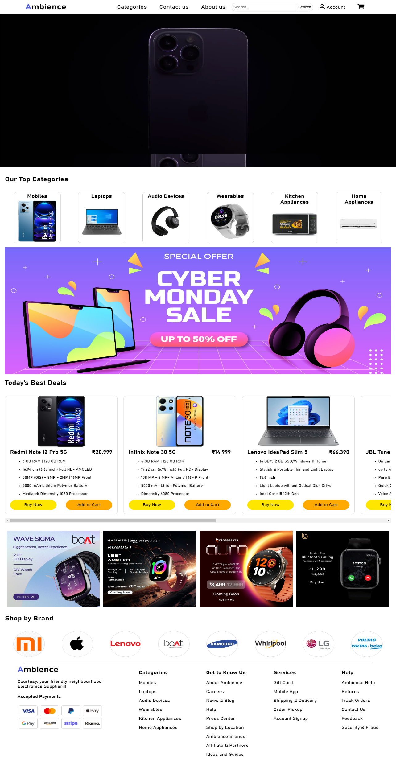

**3.3 About Us:**

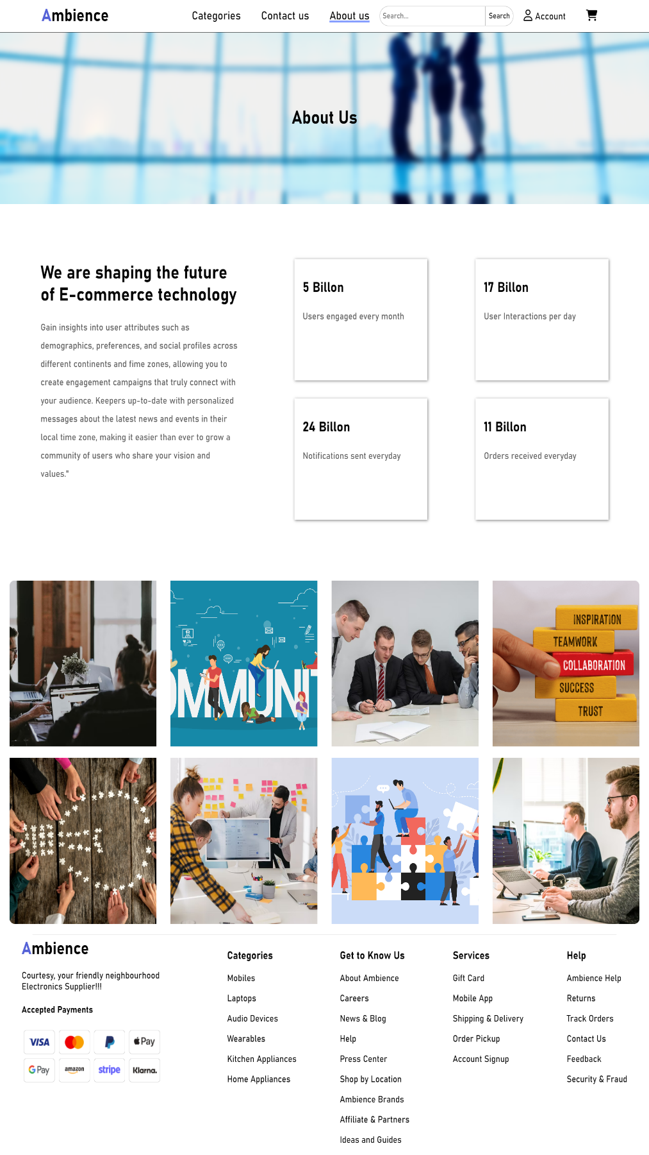1. The About Us page provides

essential information about your brand and its mission.

2. The page begins with a navigation menu that offers easy access to key sections of the site, including categories, contact details, and the "About Us" section, which is currently highlighted as the active page.

3. It showcases my company's vision of shaping the future of e-commerce technology.

4. It emphasizes gaining insights into user demographics and preferences, fostering user engagement, and keeping users informed with personalized messages.

5. This data-driven approach is further underscored with statistics about user engagement, interactions, notifications, and orders.

6. Additionally, the page features a visually engaging section with pictures that can help convey the personality of my brand.

* 1. **Categories Page:**

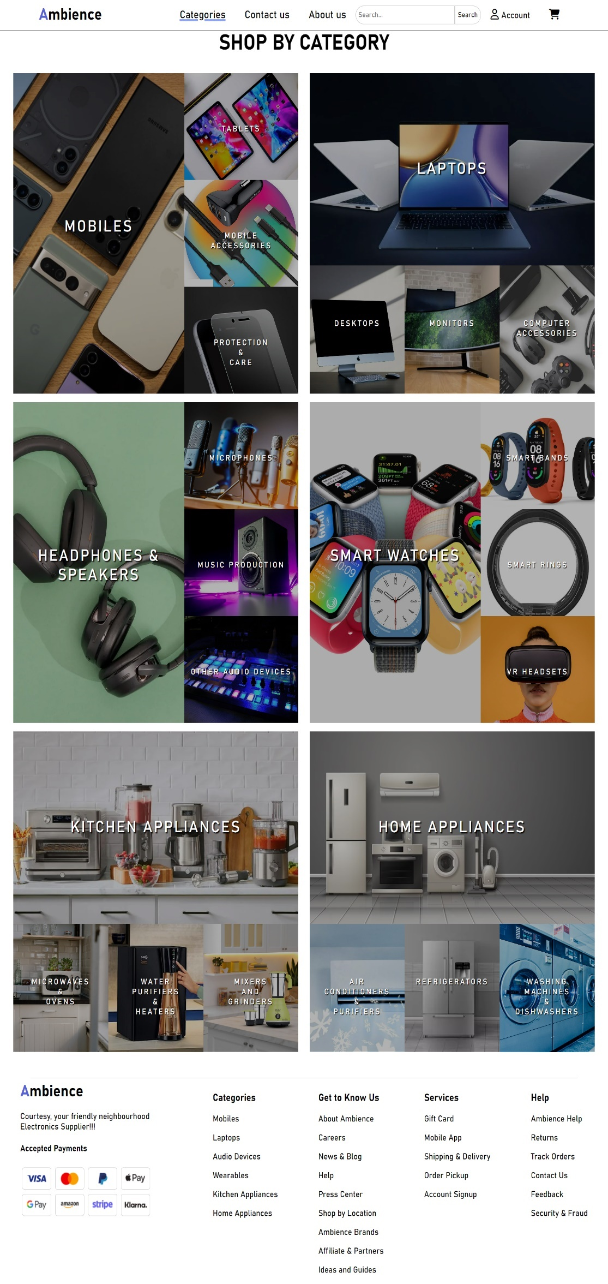

1. The "Categories" page provides a clear and organized structure for users to explore and shop for products.

2. The page presents various product categories, each with a main subcategory and related subcategories, making it convenient for users to narrow down their product searches.

3. Overall, this "Categories" page is designed to streamline the shopping process, making it easy for users to find and explore products in an organized and user-friendly manner.

* 1. **Contact Us Page:**

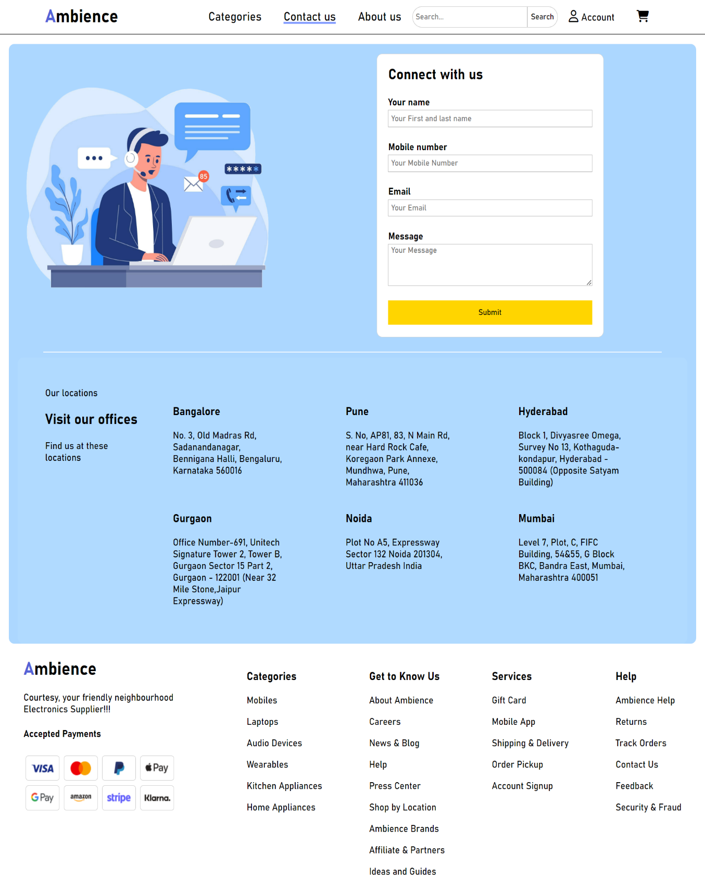

1. The "Contact Us" page serves as a vital communication channel between customers and the company. The header includes easy navigation, with "Contact Us" highlighted as the active section, making it straightforward for users to get in touch.
2. The main content of the page presents a contact form, allowing customers to reach out to the company. The form prompts users to provide their name, mobile number, email, and a message. This user-friendly interface facilitates effective communication. Additionally, the page features a map-like graphic to showcase your various office locations, along with addresses, making it convenient for customers to find us physically.
   1. 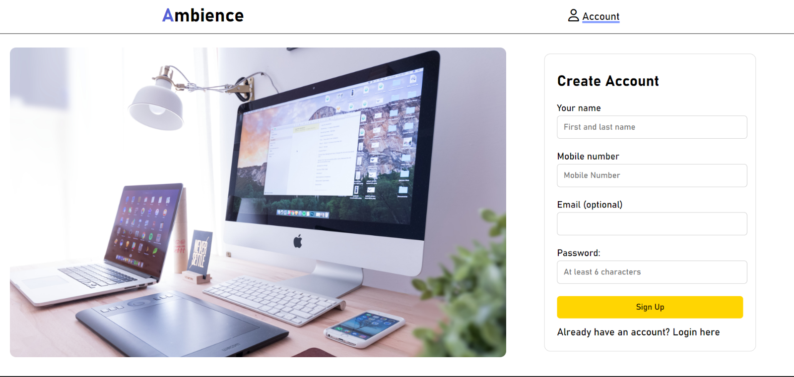**Signup / Login Page:**

1. The "Signup" page offers an intuitive and convenient way for users to create an account. The page maintains a clean and straightforward design, ensuring a seamless user experience. It presents a registration form that prompts users to provide their name, mobile number, email (optional), and a password of at least 6 characters.

2. The form encourages new users to sign up by providing essential personal information while keeping the process user-friendly. Additionally, the option to "Login here" is provided for those who already have an account, enhancing user navigation.

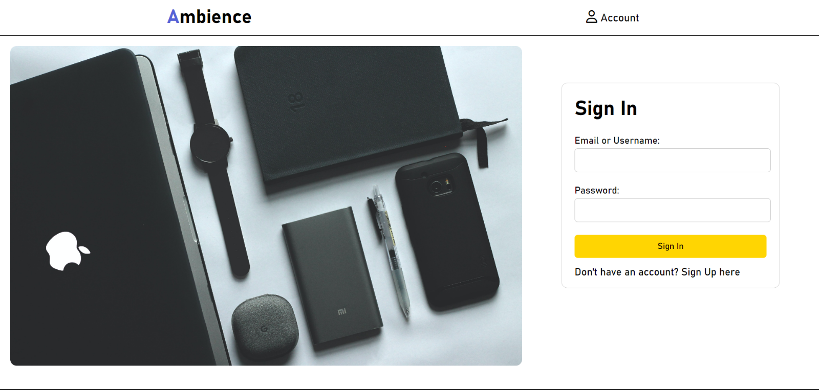

1. The "Login" page provides an efficient and straightforward way for users to access their accounts. The page offers a clean and visually appealing design, ensuring a user-friendly experience. Users are prompted to enter their email or username and password, making it easy to log in securely.

2. Additionally, the "Sign In" button simplifies the login process. For new users, a "Sign Up here" link is conveniently provided, encouraging them to create an account. Overall, this "Login" page is designed with user convenience in mind, making it easy for both existing and new users to access their accounts or register.

* 1. **Product Category Page:**

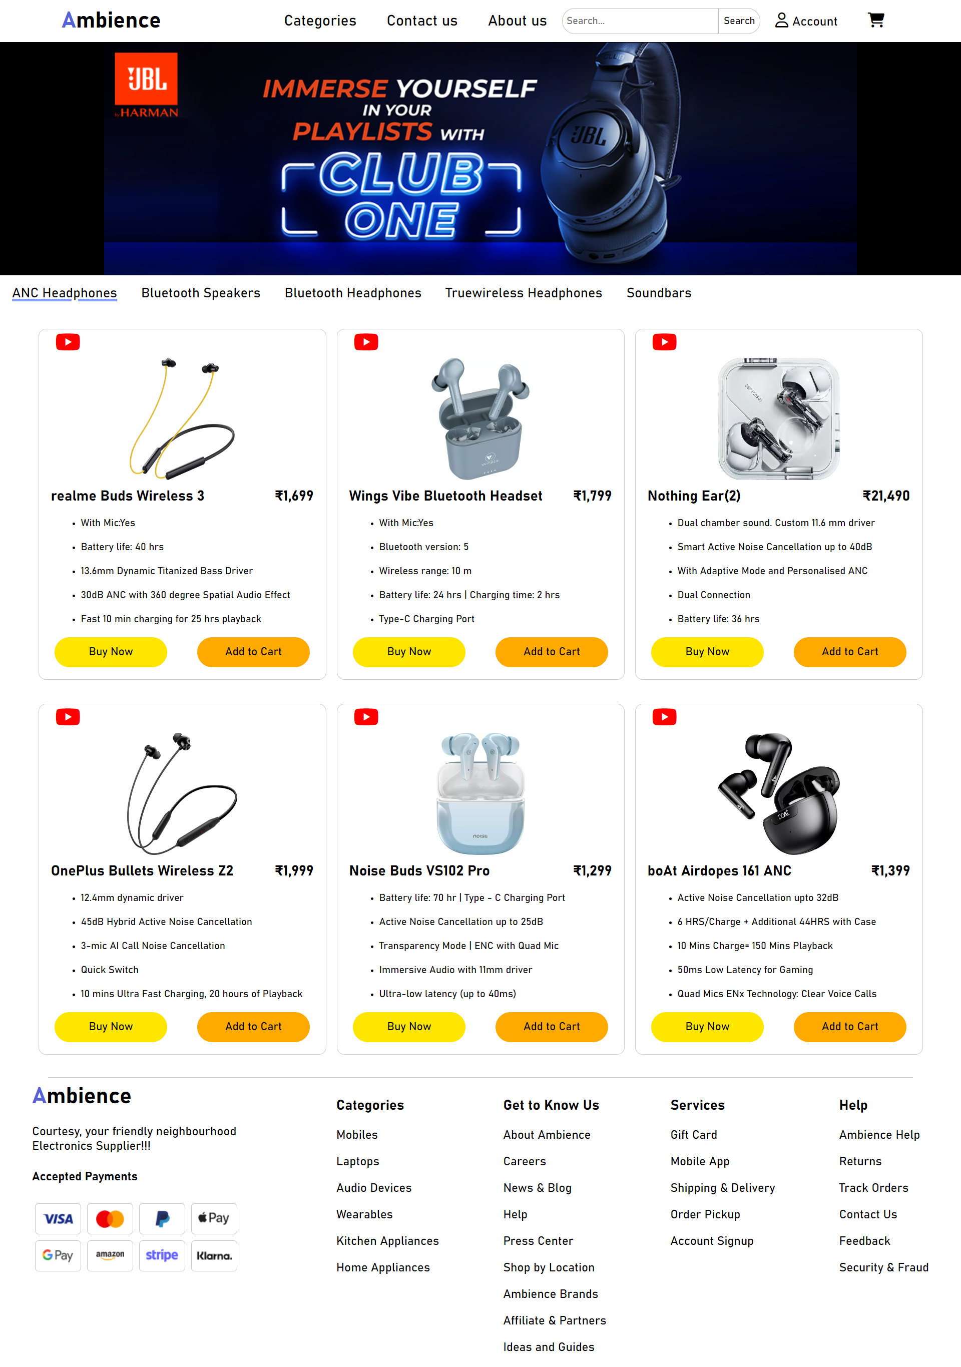

1. The "Product Category" page, specifically the "Audio-devices" section, is a well-structured and visually engaging platform for showcasing a wide range of audio-devices. The page is divided into different tabs, which divide different type of audio devices.

2. The dynamic and interactive layout presents various audio devices with detailed information and video previews, enhancing the shopping experience. Each product is accompanied by a concise description, price, specifications, and options to "Buy Now" or "Add to Cart.". Overall, the Product category pages are designed to attract and inform potential customers while facilitating seamless browsing and purchasing.

* 1. **Product Overview Page:**

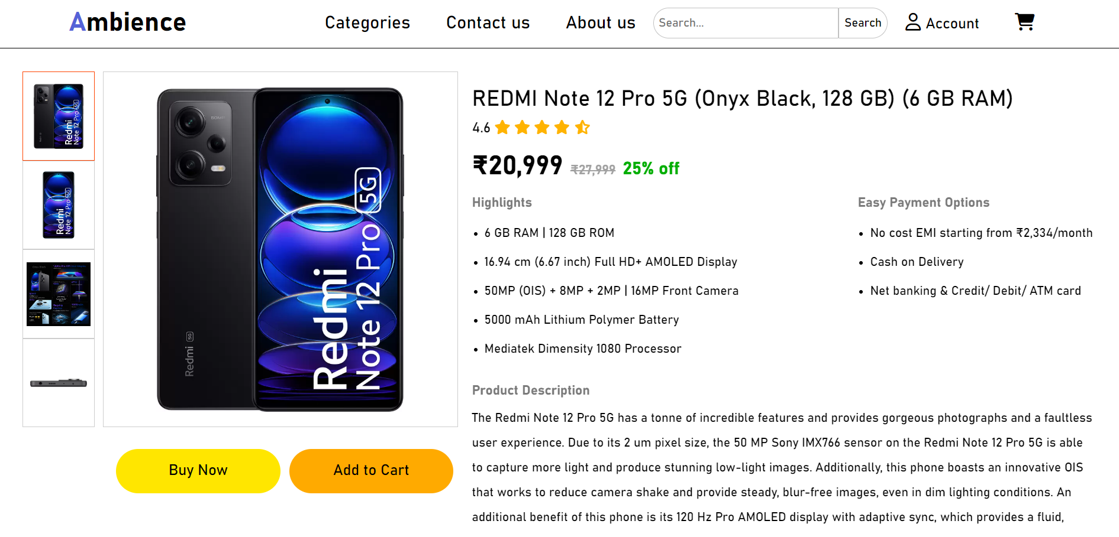1. The "Product Overview" page for the Redmi Note 12 Pro 5G offers a comprehensive and visually engaging presentation of this mobile device. The page is thoughtfully structured, with high-quality images and essential product information, making it easy for customers to explore the device's features, specifications, and pricing.

2. JavaScript allows users to interact with the product images. When a user clicks on one of the small additional images (add-pic), the associated main image (main-pic) changes to show that view of the product. This feature helps users examine the product from different angles.

3. Shoppers can quickly grasp the key selling points, such as the 6 GB RAM, 128 GB ROM, impressive camera capabilities, and a discounted price of ₹20,999. Detailed highlights, easy payment options, and a thorough product description provide valuable insights for potential buyers.

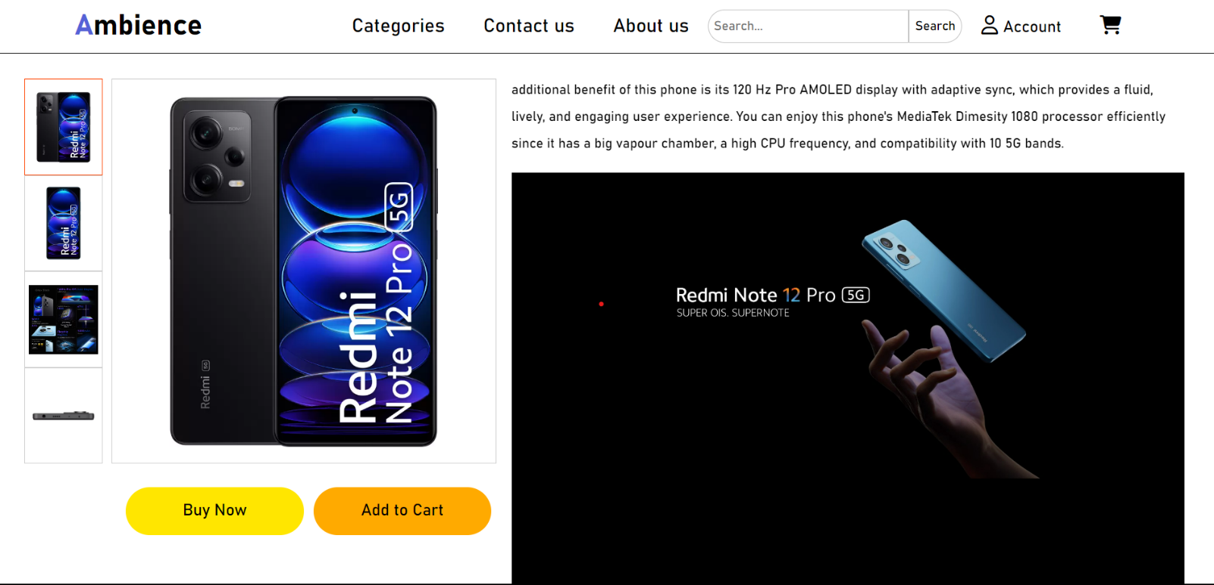

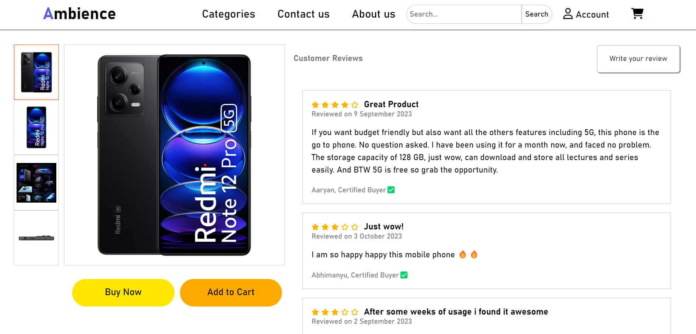4. Customer reviews and a "Write your review" button invite user interaction and feedback. Clicking the "Write your review" button opens a review submission form in a popup. The "X" button or clicking anywhere outside the popup closes it, providing a user-friendly interface for writing and submitting product reviews.

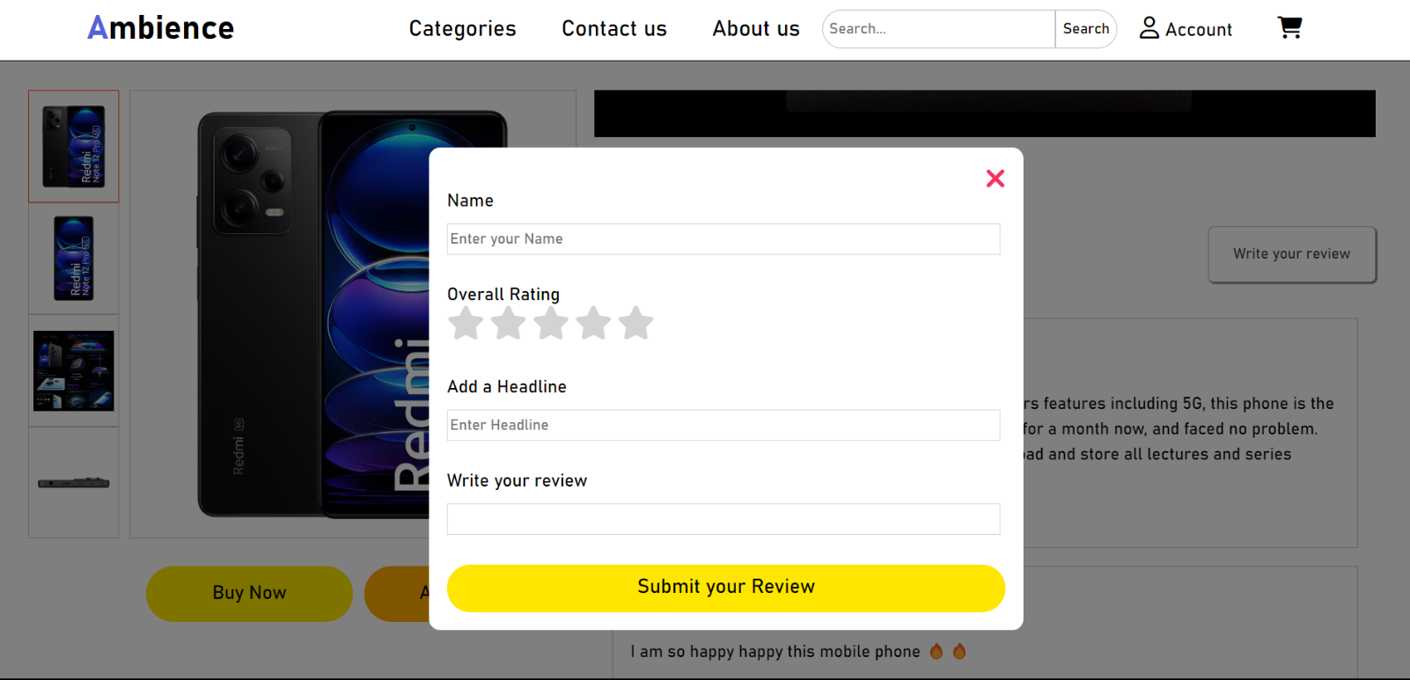

5. Javascript enables users to select their overall rating for a product by clicking on stars. On mouseover (ratingEnter), the stars change color to indicate interactivity. On mouse leave (ratingLeave), the color reverts. When a user clicks on a star (ratingClick), it records the chosen rating, providing a simple and intuitive way for customers to rate products.

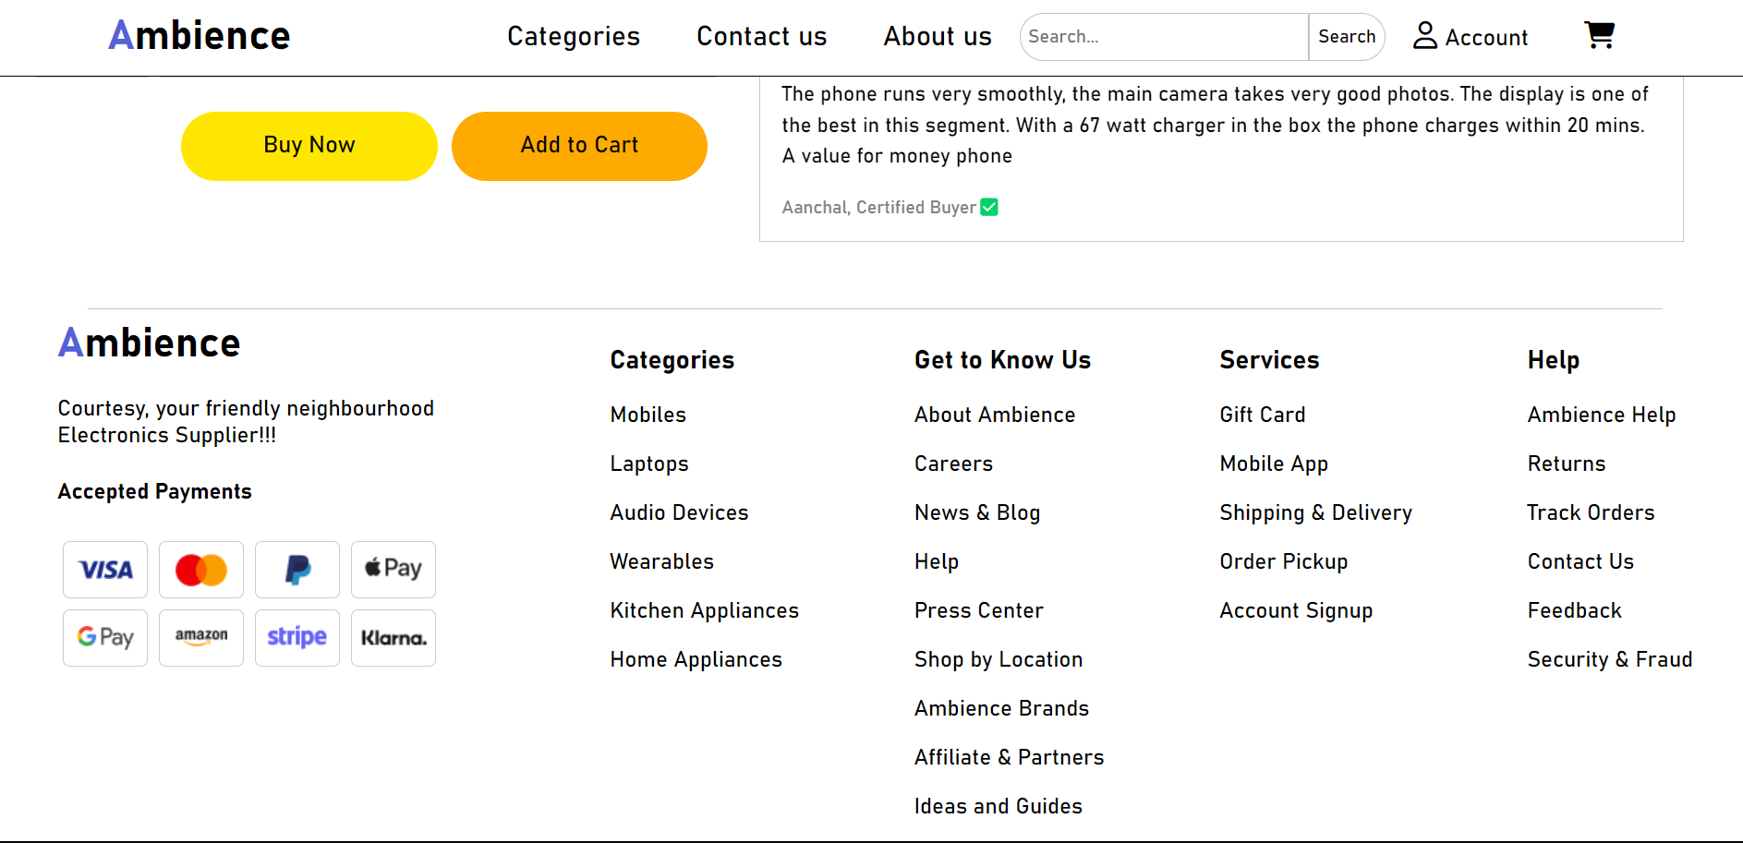

* 1. **Shopping Cart Page:**

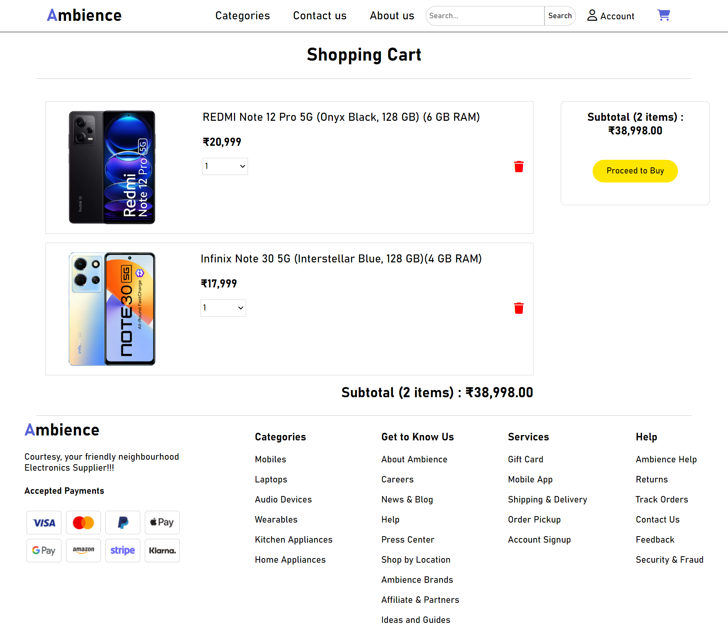

1. The Shopping Cart page provides an organized and user-friendly interface for customers to review and manage their selected items before making a purchase. The cart section lists the products selected by the user, showing each item's name, price, and a dropdown for adjusting the quantity.

2. Event listeners are attached to the quantity <select> elements for each product. When a user changes the quantity of an item in the cart, the updateSubtotal function is called, which recalculates the subtotal, ensuring that it reflects the changes in quantity.

3. The page keeps a running subtotal, displaying the total number of items and their combined price. The updateSubtotal function calculates the total price and the total quantity of items in the cart. It iterates through each product element, extracts the price and quantity, calculates the product's total cost, and accumulates these values to determine the overall subtotal.

4. Users can also remove items from their cart with a convenient "trash" button. Each product element has a delete button (trash icon) associated with it. When a user clicks this button, a confirmation dialog is shown, and if the user confirms the deletion, the corresponding product element is removed from the cart, and the updateSubtotal function is called again to adjust the total price and quantity.

5. It encourages customers to proceed to the checkout page with a "Proceed to Buy" button. This shopping cart page plays a vital role in streamlining the shopping experience for your customers and facilitating a seamless transition to completing their purchases.

* 1. **Checkout Page:**

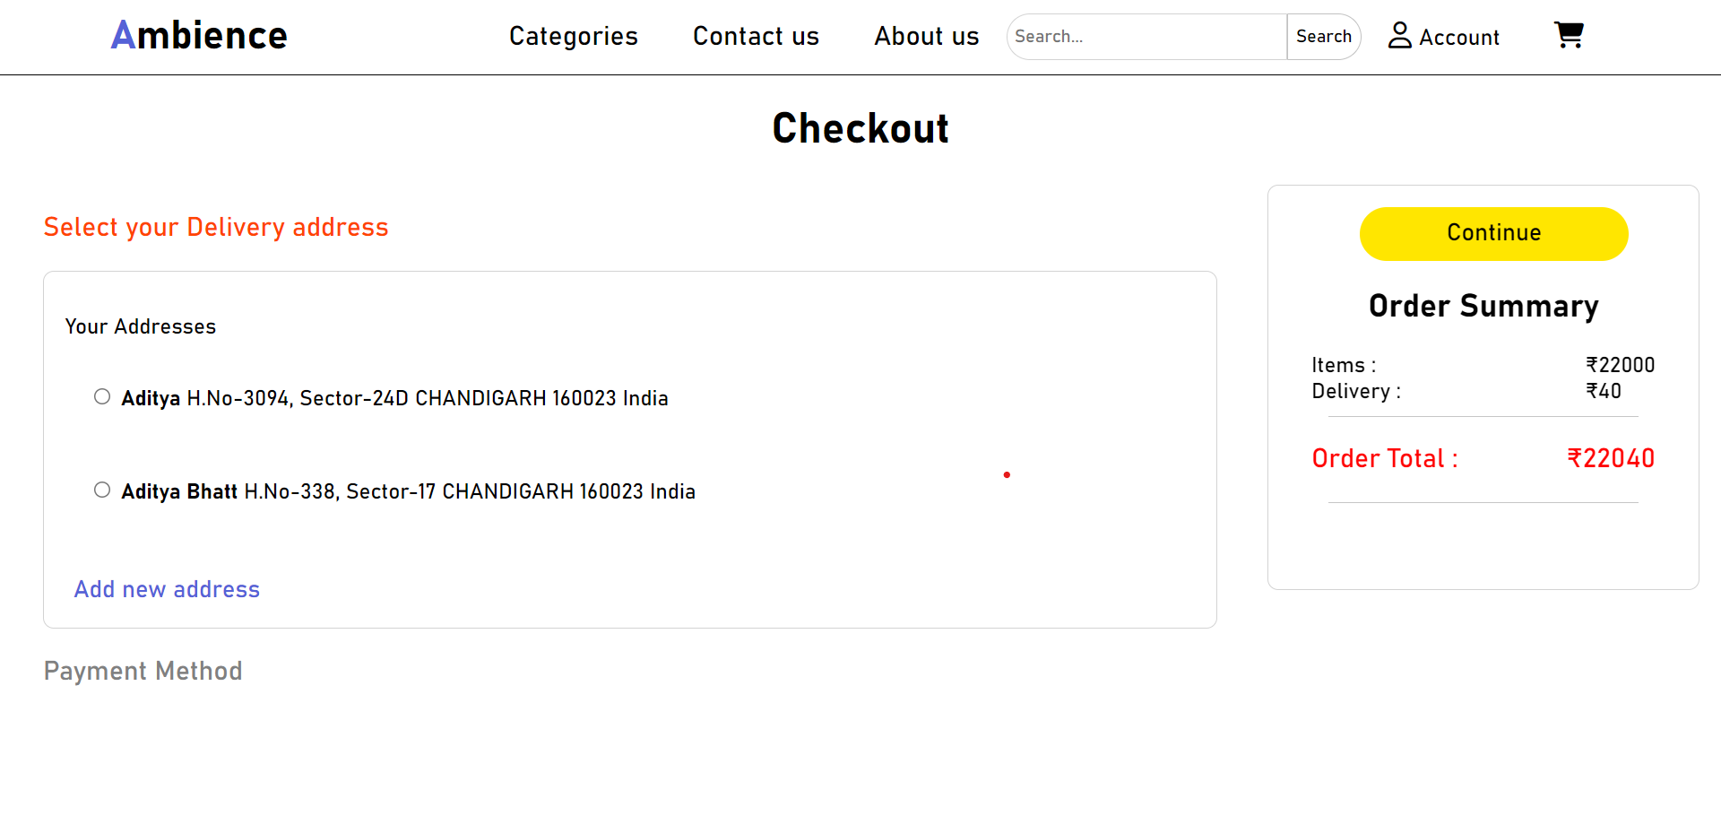

1. The Checkout page is designed to facilitate the smooth and secure completion of a customer's purchase. It is divided into two main sections: "Delivery Address" and "Payment Method." openColl function opens a collapsible section when a user clicks on a section title. It highlights the selected section and displays its content while hiding others.

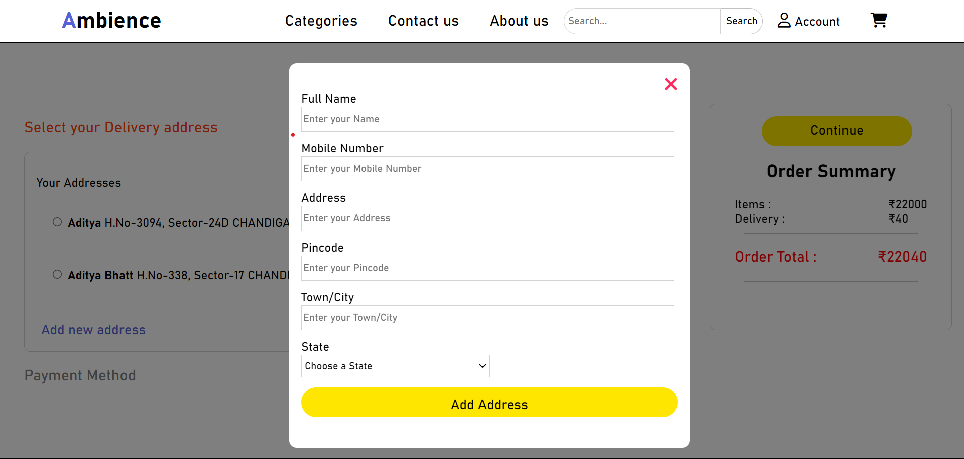

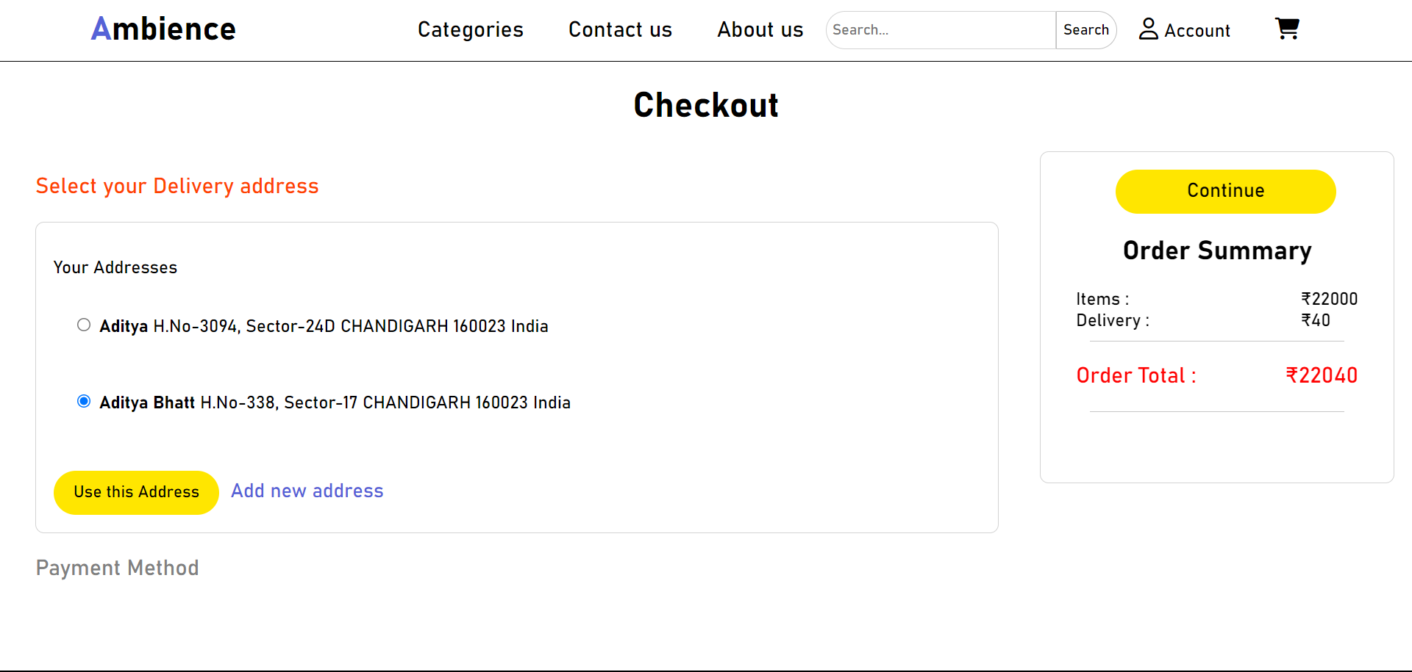

2. In the "Delivery Address" section, customers can choose an existing delivery address or add a new one. openPopup and closePopup functions open and close a popup form for adding a new address. They provide a user-friendly way to input address details. addNewAddress: When a user adds a new address in the popup form, this function creates a new address element with the entered details and appends it to the list of addresses.

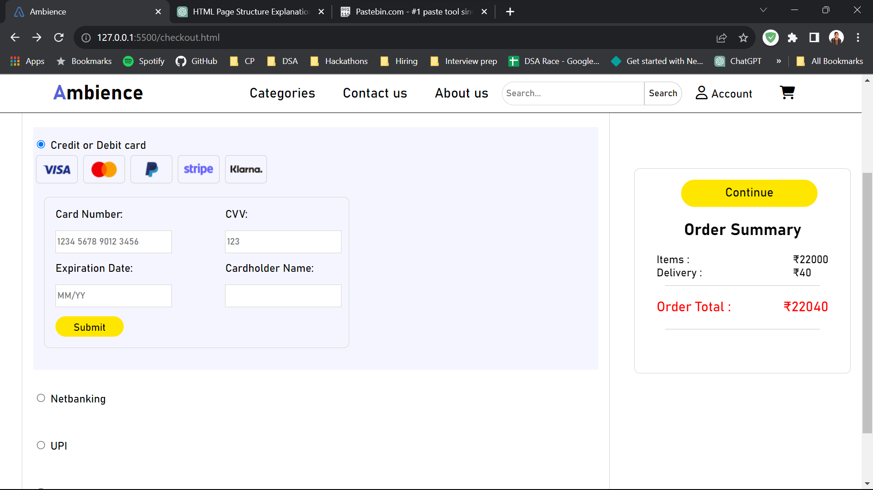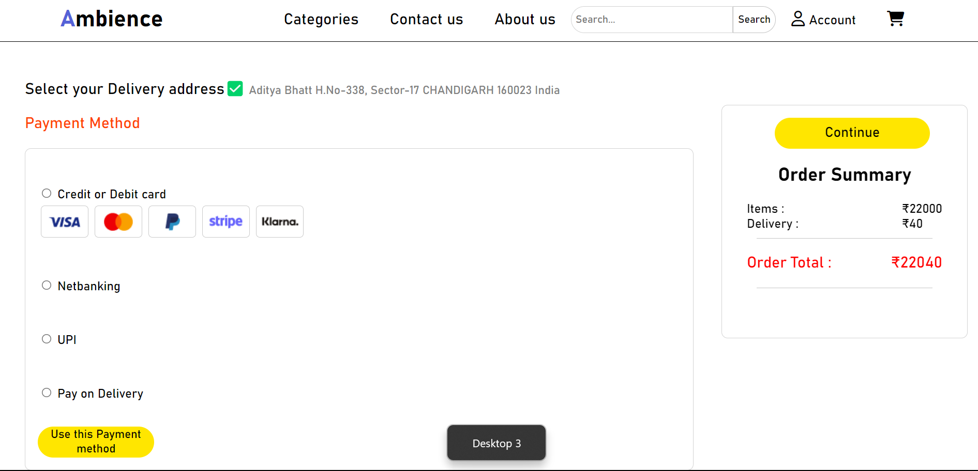

3. The "Payment Method" section offers various payment options, including credit/debit cards, netbanking, UPI, and pay on delivery. Customers can choose their preferred payment method, with associated details and visuals for cards. When the user confirms the payment method, useThisPay function hides unselected payment methods and displays the chosen one.

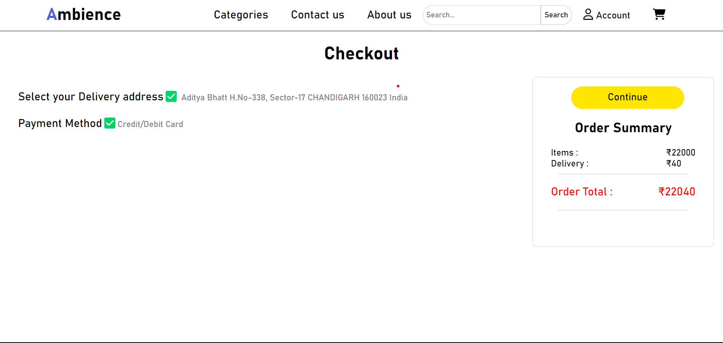

4. A real-time summary of the order, including items and delivery costs, is displayed. This page enhances user experience by providing a seamless and flexible checkout process, ensuring your customers can easily complete their purchase and make secure payments for their selected items.

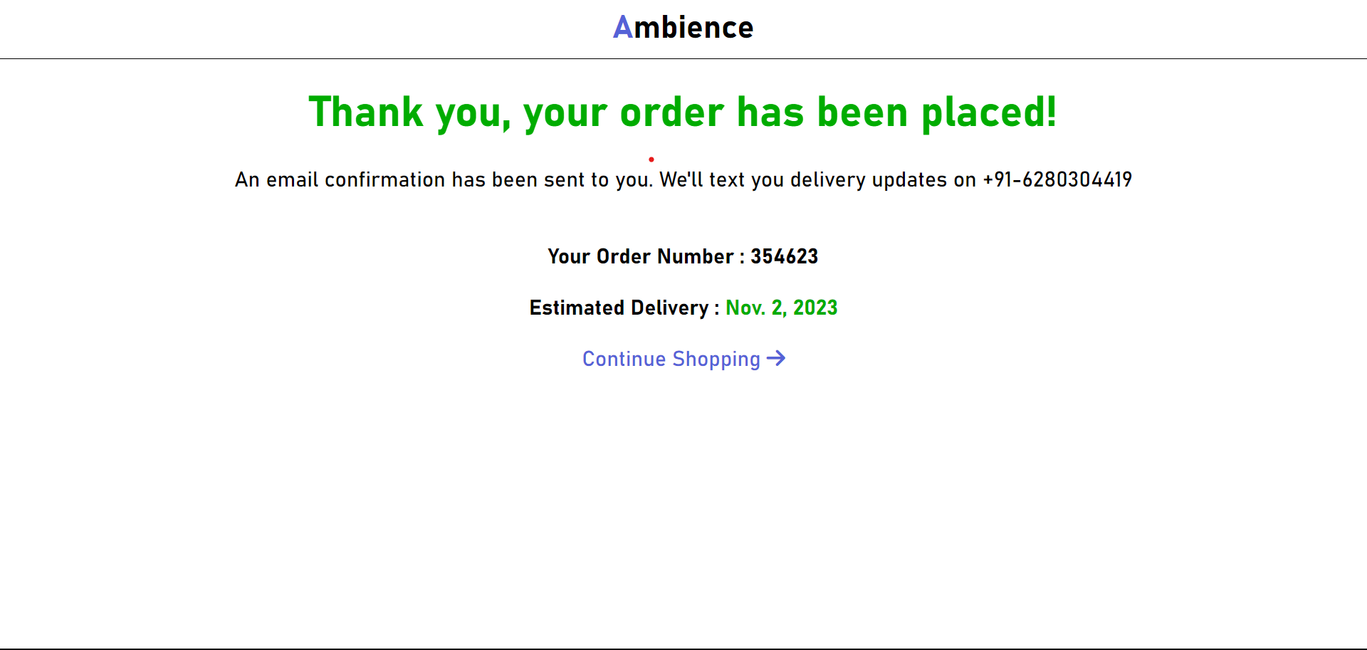**3.11 Order Confirmation Page:**

1. The Order confirmation page serves as a reassuring and informative message to your customers after they've successfully placed an order. It starts with a prominent "Thank you" message, ensuring the customers that their order has been placed.

2. The page also informs them that an email confirmation has been sent, and they will receive delivery updates via text on a provided phone number. The order number is displayed for reference, and the estimated delivery date adds a sense of anticipation. JavaScript code generates a random number and displays it as order number.

3. Finally, it offers customers the option to continue shopping, maintaining a user-friendly and seamless shopping experience. Overall, this page plays a crucial role in keeping your customers informed and satisfied while encouraging further engagement with your e-commerce platform.

**CHAPTER 4: WHY NAME *Ambience*?**

The choice of the name *Ambience* can be influenced by several factors:

* **Atmosphere and Environment:** *Ambience* typically refers to the atmosphere or environment of a place. It conveys a sense of setting, mood, and surroundings. For an e-commerce website, this name suggests that our platform offers a wide range of electronic products, accessories, and gadgets that can enhance or transform the ambience of a space or environment.
* **Brand Identity:** The name *Ambience* can create a strong brand identity that emphasizes the quality and aesthetics of the products we sell. It might imply that customers can find high-quality and stylish electronic items that contribute positively to their surroundings.
* **Memorability:** Short, unique, and easy-to-remember names are often preferred for e-commerce websites. *Ambience* is relatively short and distinctive, making it easier for customers to recall when they think of purchasing electronics.
* **Broad Appeal:** The term *Ambience* does not pigeonhole the website into a specific niche within electronics. It allows us to offer a wide range of products, from home electronics to personal gadgets, without the name feeling too narrow in focus.
* **Positive Connotations:** The word *Ambience* generally has positive connotations. It implies a pleasant or desirable environment, which can be an attractive message to potential customers.
* **Availability:** When choosing a name for a website, domain name availability is crucial. *Ambience* is a relatively unique and available domain name, which can be a practical consideration.

**CHAPTER 5: Future Scope**

* **Mobile App Development:** We will consider developing a dedicated mobile application for *Ambience* to provide a seamless and optimized shopping experience for mobile users.
* **Personalization and AI:** Implementing advanced personalization techniques and artificial intelligence to provide customers with product recommendations, personalized content, and a tailored shopping experience.
* **Progressive Web App (PWA):** Transforming the website into a PWA to offer offline access, push notifications, and a more app-like experience for users.
* **Augmented Reality (AR) Integration:** Allowing customers to visualize appliances in their own space using AR technology, which can enhance the decision-making process.
* **Voice Commerce:** Enabling voice search and voice-assisted shopping for hands-free browsing and ordering through voice-activated devices.
* **Subscription Models:** Introducing subscription services for regular appliance maintenance, filter replacements, or exclusive access to new products.
* **Global Expansion:** We will consider expanding our e-commerce platform to serve customers in different regions and countries to tap into a broader market.
* **Cross-Selling and Upselling:** Develop cross-selling and upselling strategies to increase the average order value by recommending related products or premium versions.
* **Enhanced Analytics and Data Insights:** Utilize advanced analytics tools to gain insights into user behaviour, sales patterns, and inventory management, which can guide business decisions.
* **Social Commerce:** Integrating social media features to allow users to discover products through social networks, share their purchases, and interact with our brand on social platforms.